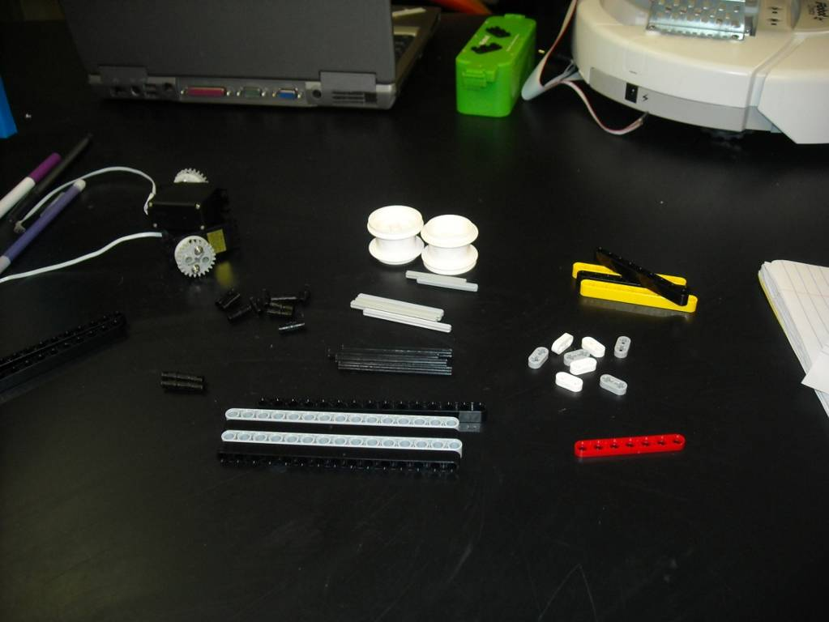
4 15-hole Lego 11 regular pins 2 11-hole Lego 2 long pins
4 9-hole Lego 2 motors
1 thin 7 whole Lego 2 wheels
4 8-axels* 8 lift arms thins
2 7-axels 4 screws
2 5-axels 2 gears
2 6-axels 2 white motor horn
2 Bushings

*Axels are measured compared to Legos

Steps:
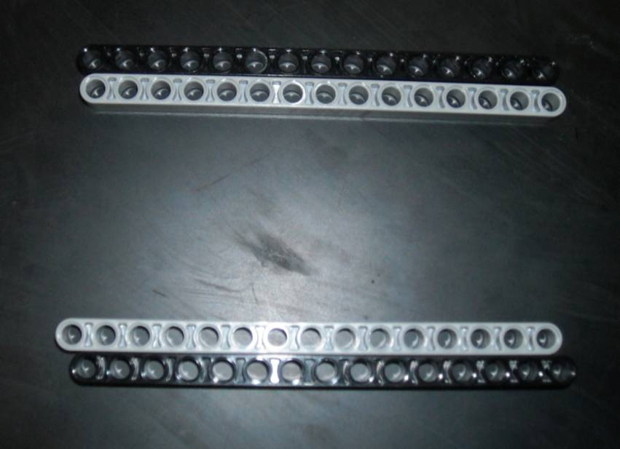
- Take all 4 fifteen-Legos and put them in groups of 2 parallel Legos.

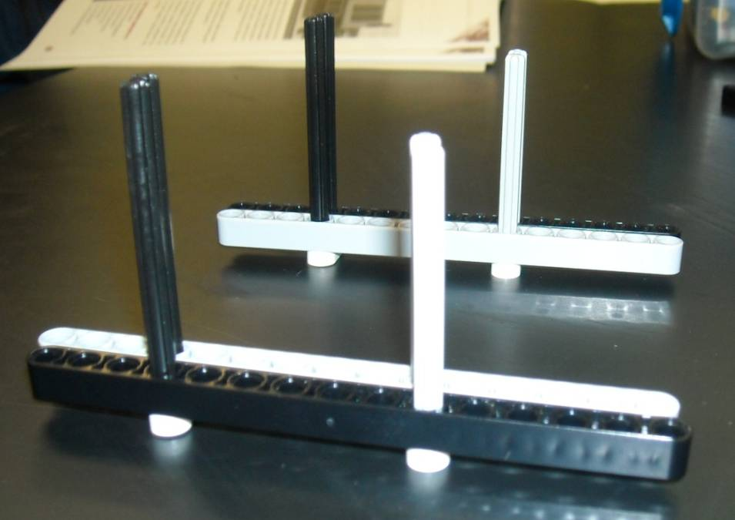
- Take 2 eight-axels and put them four holes from the end securing the axels with liftarm thins
- Take two 6 axels and put them seven holes from the opposite ends of the legos
- Repeat the same step on the other set of parallel fifteen-legos
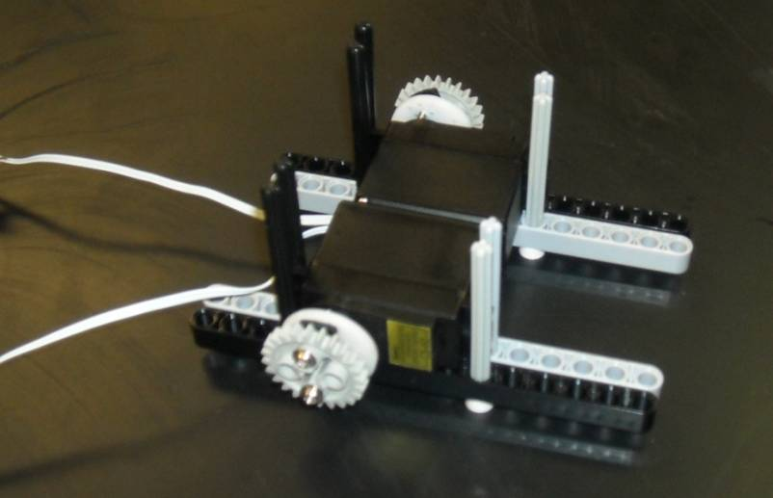
- Place motors between the sets of axis

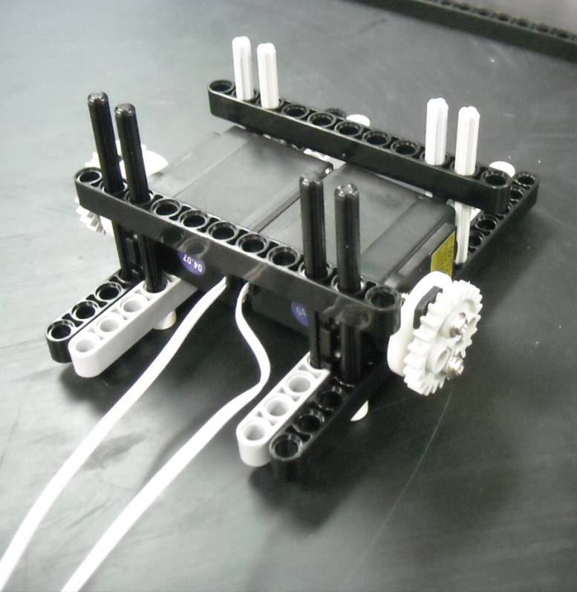
- Place 2 eleven-legos over the axel sets (there should be one extra hole on either side) perpendicular to the fifteen-legos

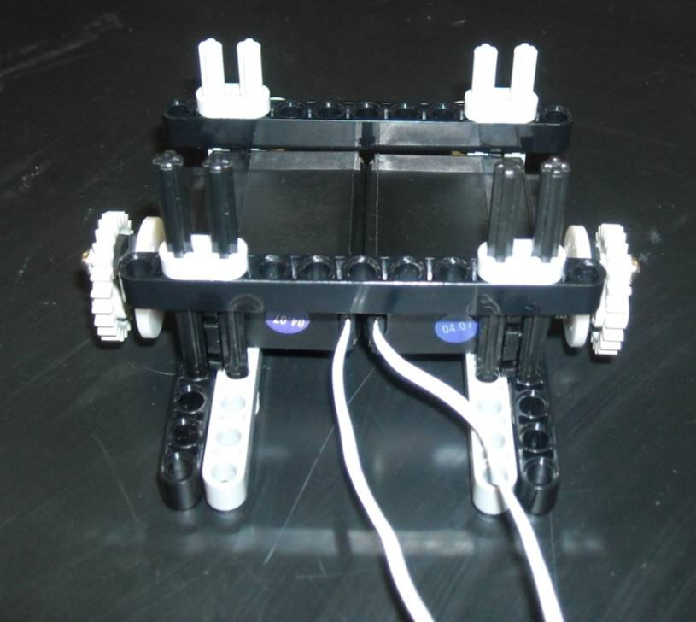
- Place 4 liftarm thins to secure the axels

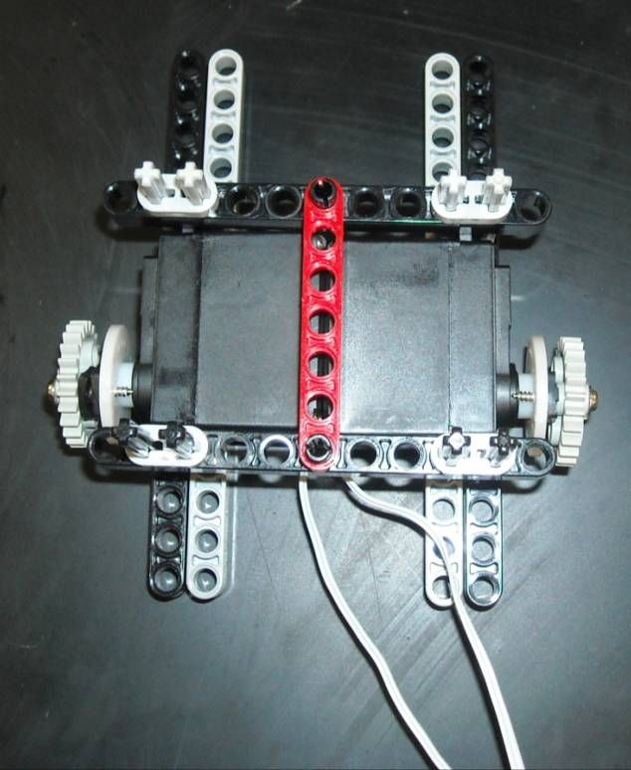
- Put a pin in the center hole; do the same on the opposite side. Then place the thin seven-lego over the pins
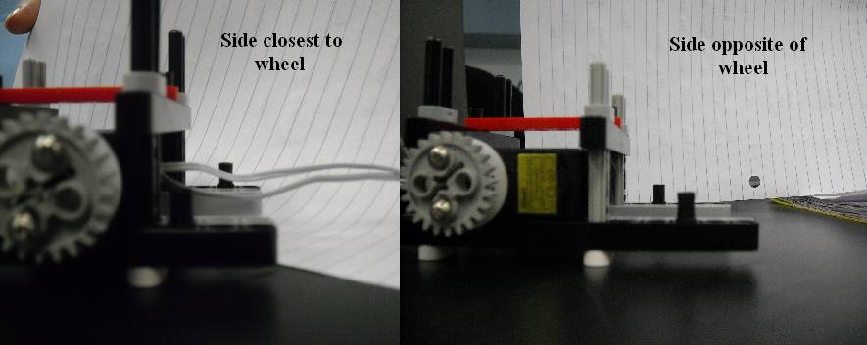
- Put in 2 pins on each crossing lego three holes from the ends on the outside legos. Put 2 more pins in on the opposite sides two holes in from the end
- On the opposite side put one pin in three holes from the end; put another pin four holes from the end.

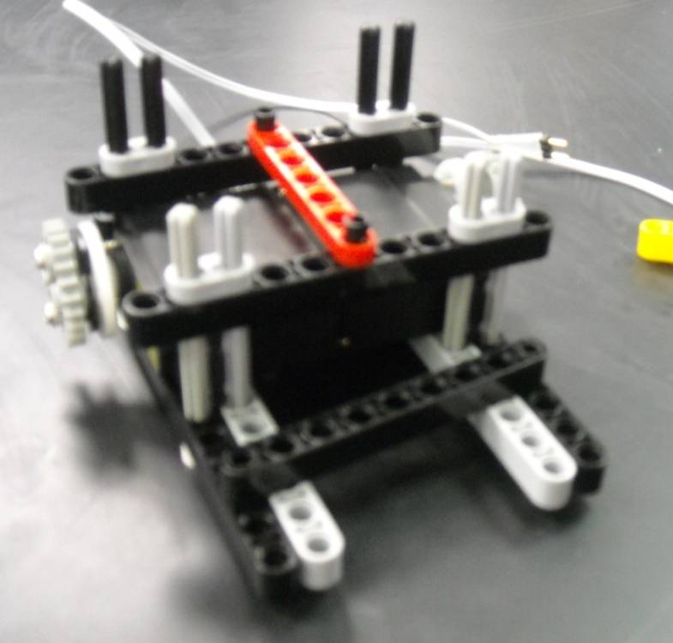
- Place 2 nine-Lego across both sets of pins
- Look at the bottom; put 2 long pins on the middle of the crossing legos (legos put on in step 9) on either side of the motor

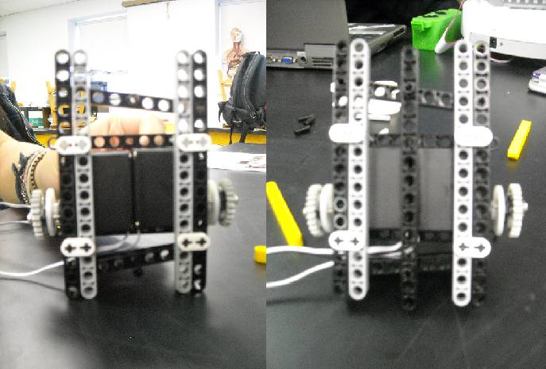
- Place the final fifteen-lego so there are two wholes on either side of the lego

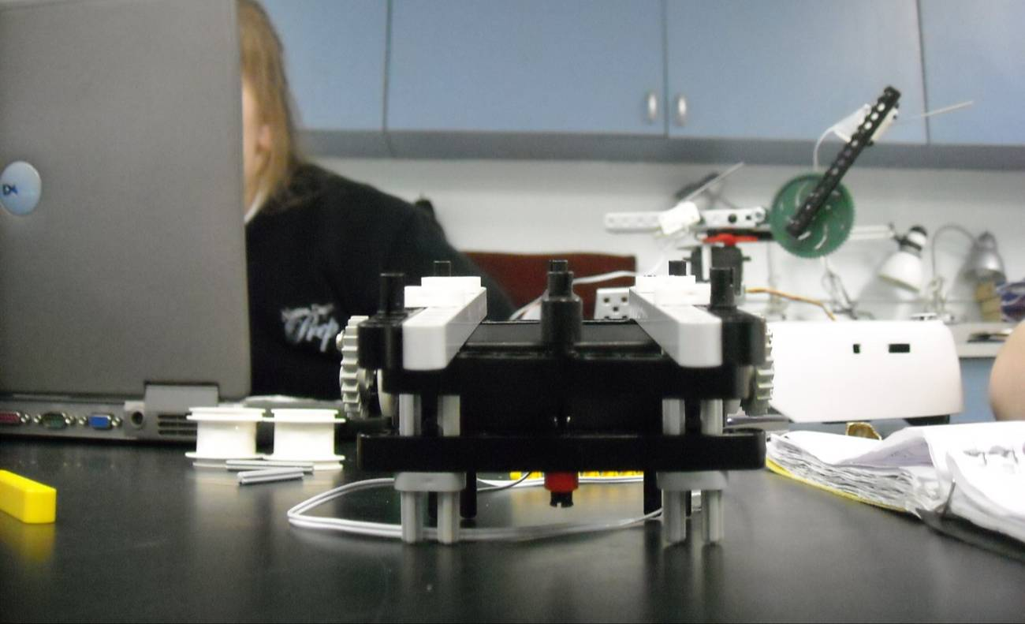
- Put 4 pins in; 3 holes in one side, 4 holes in the other
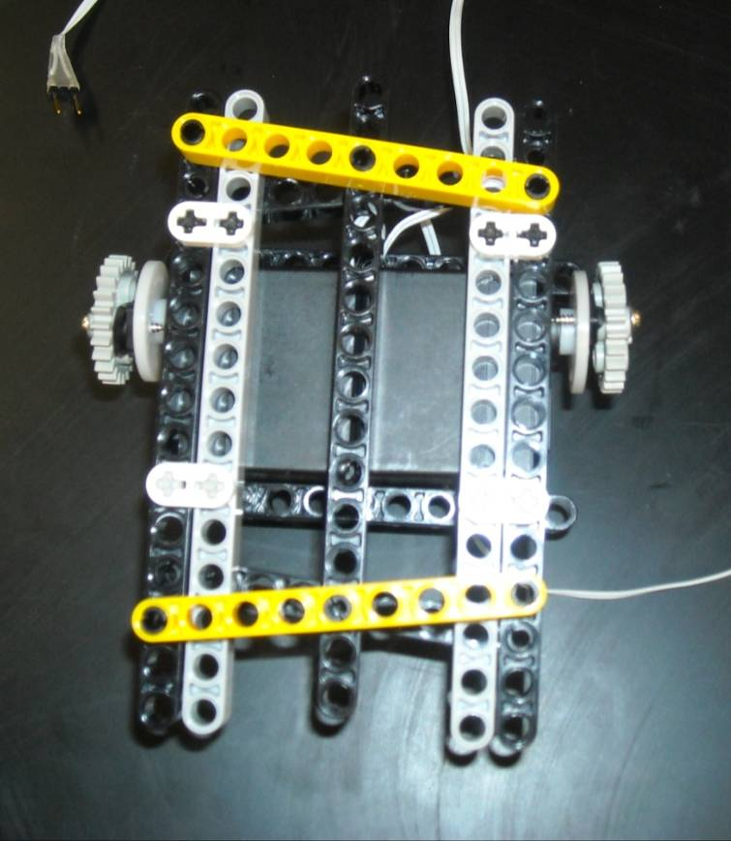
- Put both eleven-legos across the pins

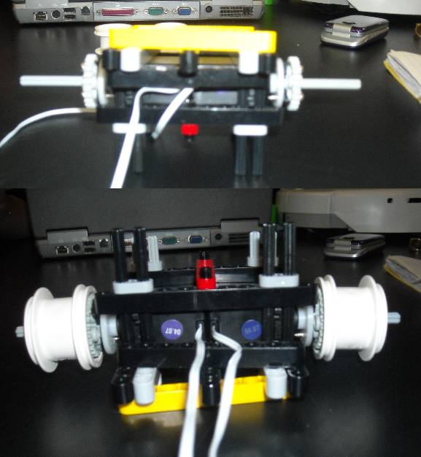
- Place an axel into the gear; place a wheel over axels and secure each with a bushing

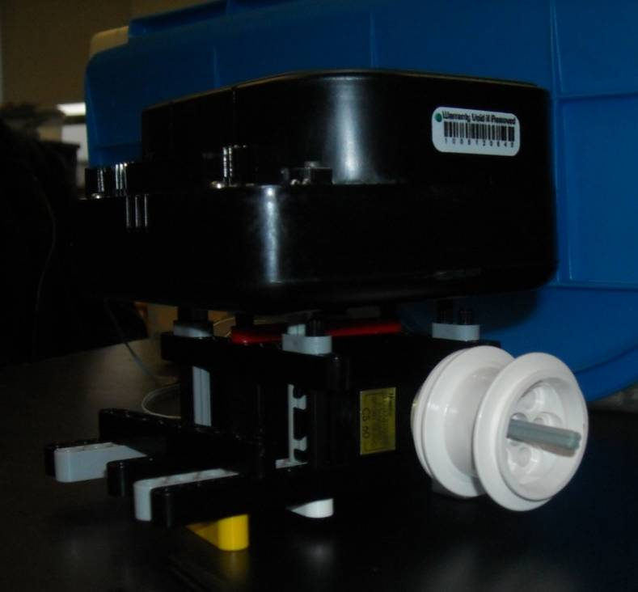
- Put on CBC

